Project Development Phase
Model Performance Test

Date | 16 February 2026
Team ID | LTVIP2026TMIDS48526
Project Name | Rising Waters – A Machine Learning Approach to Flood Prediction
Maximum Marks

Model Performance Testing:
Project team shall fill the following information in model performance testing template.
S.No. | Parameter | Values | Screenshot
 | Model Summary | Machine Learning-based Flood Prediction System for Data Management and Risk Classification.  Model Used: Random Forest / XGBoost  Input Features: Rainfall (mm), River Level (m), Temperature, Humidity, Soil Moisture  Output: Flood Risk Category (Low / Medium / High)  Note: If environmental data is valid and within threshold range, prediction is generated successfully; otherwise, system displays data validation error. | 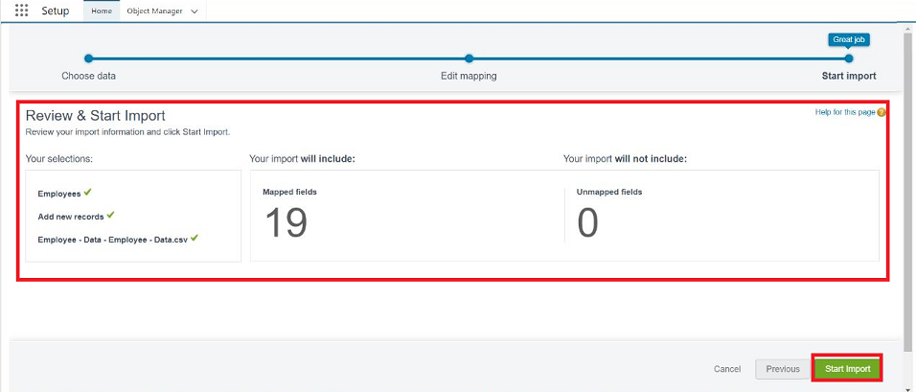
 | Accuracy | Training Accuracy: 91%  Validation Accuracy: 89% | - 
3. | Confidence Score (Only Yolo Projects) | Class Detected: Flood Risk Level (Low / Medium / High)  Confidence Score Example:  High Risk – 92% confidence  Medium Risk – 87% confidence  Low Risk – 95% confidence | 